Practical Task 05
CSC-369

Semester 7

Digital Image Processing

Task 1:
Download 2 grayscale images (8-bit) of HD resolution 1280x720 pixels. Image 1 will be used as the cover image, and the data from Image 2 will be used as secret information. Image 1 should have rapidly changing intensities, while image 2 should have regions where the pixels have similar values. Display both the images.

Code:
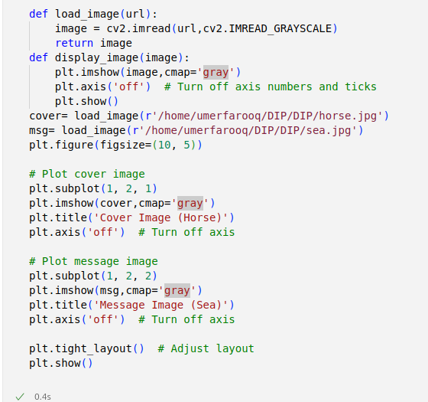
Output:
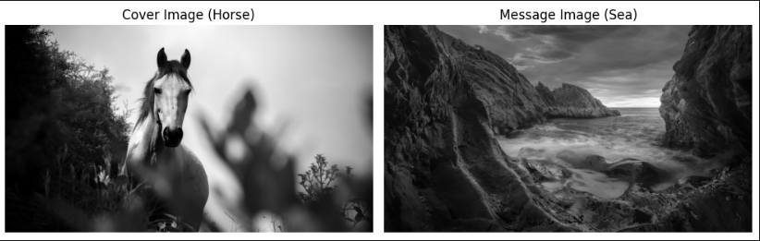

Task 2:
Display all 8 bit-planes of image 1 separately

Code:
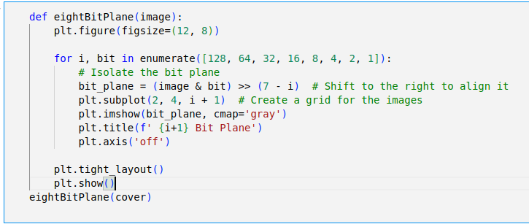

Output:
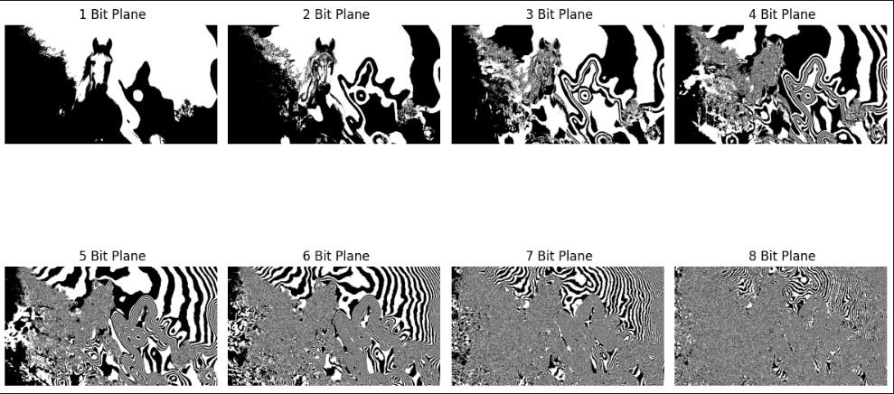
Task 3:
Implement the steganography algorithm to hide one bit of the second image in the cover image. Display Image 1 containing hidden information. At the receiver end, extract the hidden information and display it.
Code:

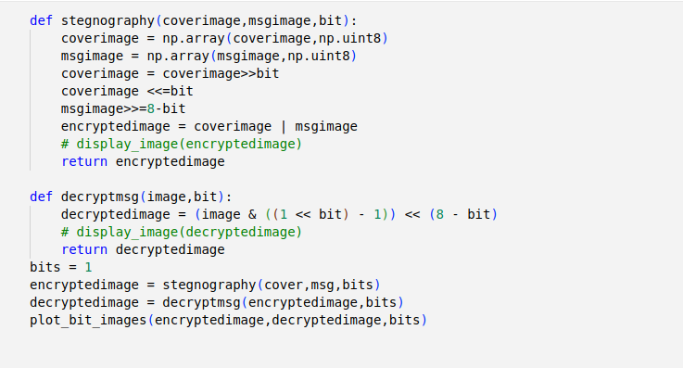
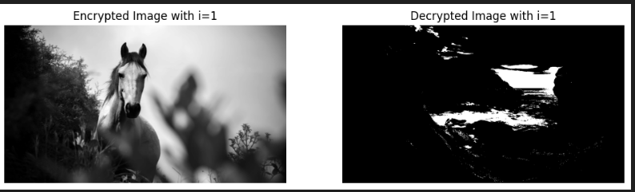
Output:

Output:
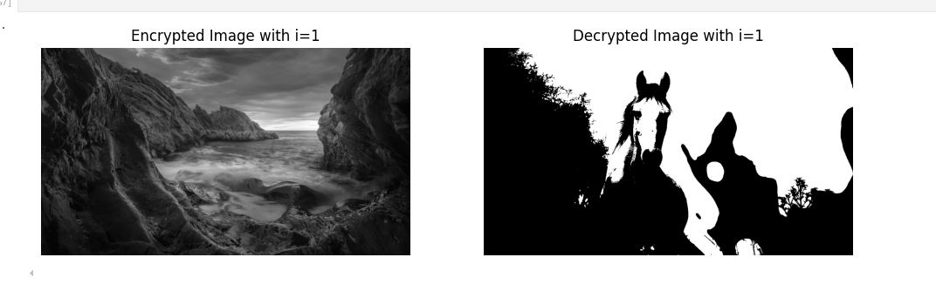
Task 4:

Repeat the above process to hide 2-bits, 3-bits, 4-bits, 5-bits, 6-bits, and 7-bits of image 2 in the cover image. Display the corresponding images, i.e. cover image with hidden data and the extracted hidden data.
Code:
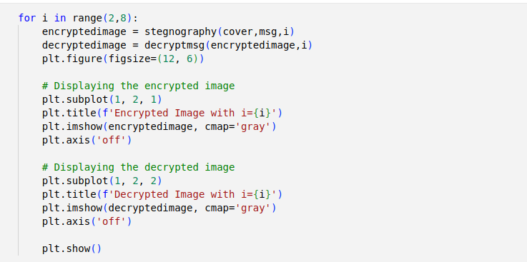

Output:

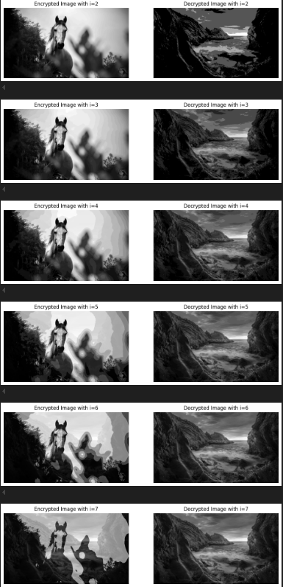

Task 5:
Now, change the roles of the two images and repeat the above-mentioned steps.

Code:

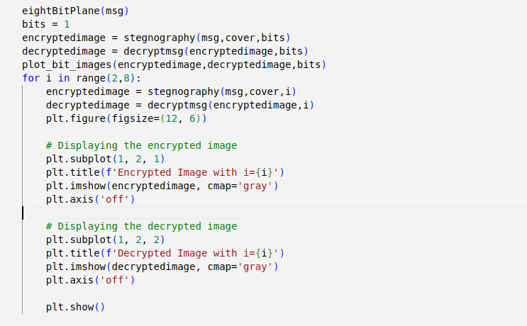

Output:
